**Lab 3A : INVOICE_CLASSIFICATION_AGENT Setup Instruction**

This lab shows how to create an agent and a simple flow that accepts a tax invoice from the user and validates it against specific rules to determine if the invoice is valid. The output will be a validation result indicating whether the tax invoice passes all the required validation rules.

Prerequisites

* Access to the Studio UI where agents and flows are created.

**Steps**

1. Create the agent  
   1.1 Choose create from scratch  
   1.2 Create a new agent named *tax_invoice_validation_agent*  
   1.3 Set the description to :  
   *This agent validates tax invoices against specific rules including date validation, company address verification, and tax ID validation. The output will be a validation result indicating if the invoice passes all rules.*

1. Add a Tool that Using a New Flow

2.1 In the agent settings, open the Toolset section and click **Add tool**.

2.2 Choose **Create a new flow**.

2.3 Click the flow title (usually Untitled) in the top-left to open the flow settings.

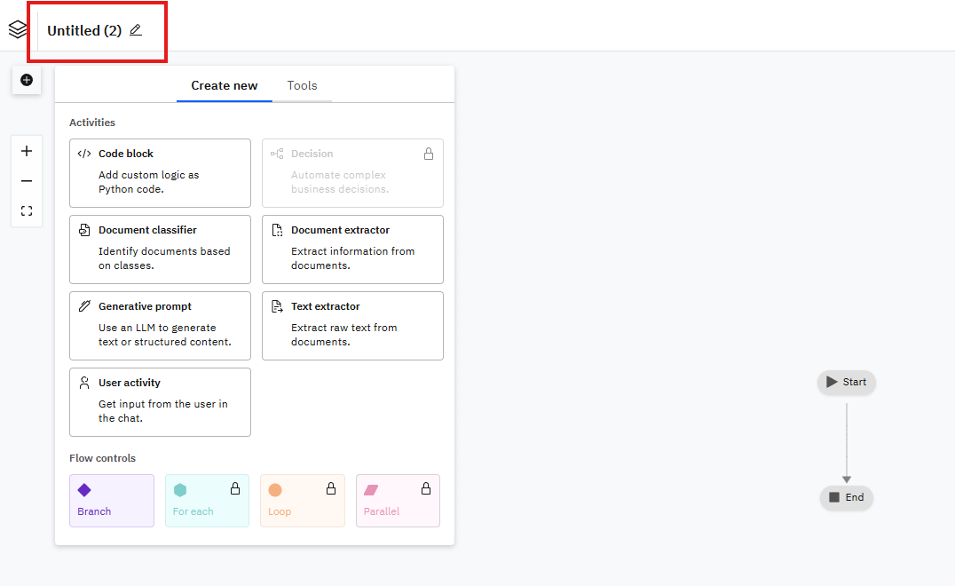

2.4 Change the tool name to tax_invoice_validation_tool and set the description to This tool validates tax invoices against predefined rules for date, address, and tax ID validation.  
2.5 Click Save.

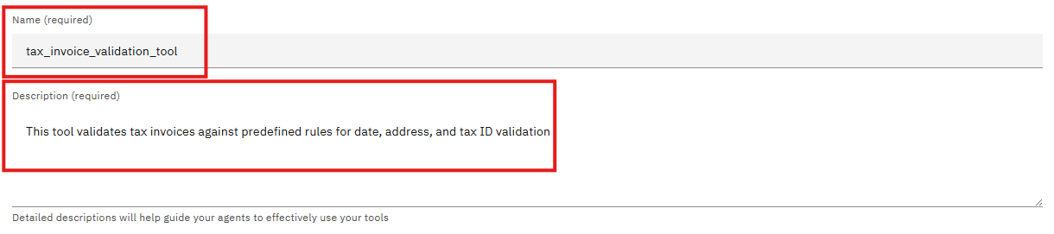

**Create the workflow**

1. Add a User Activity node

* Hover over the connection line between Start and End until a plus (+) appears.
* 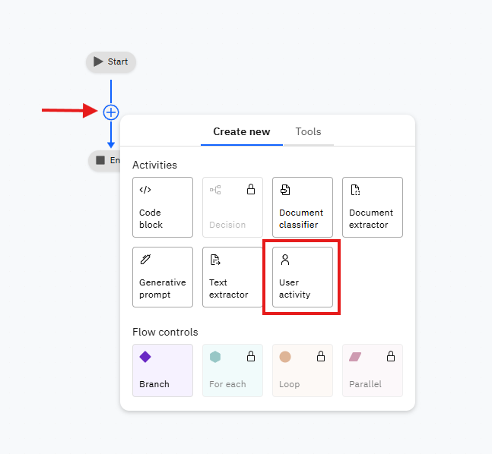Click the plus icon and select  User activity  from the menu.

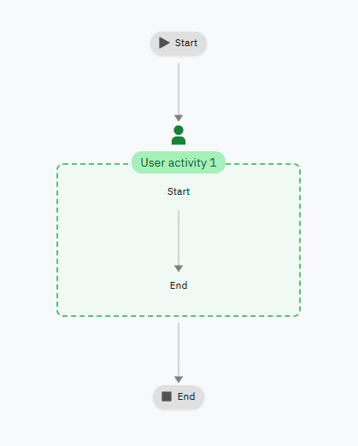

1. Ask the user to Upload Tax Invoice

* Edit the User Activity node's display name to: กรุณาอัปโหลดใบกำกับภาษี

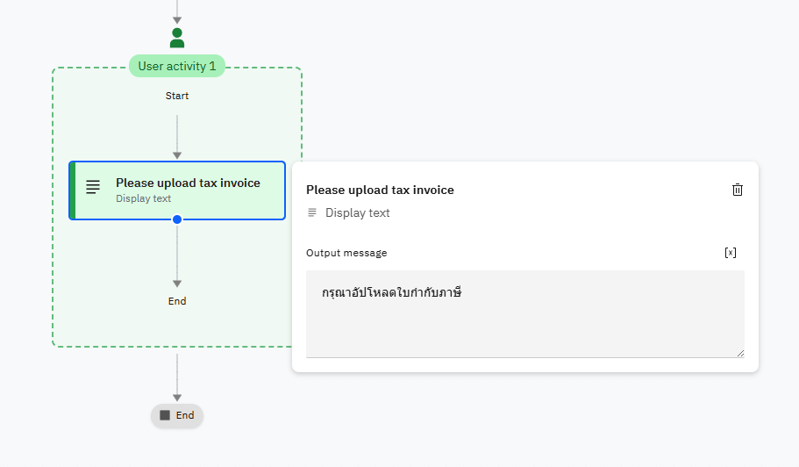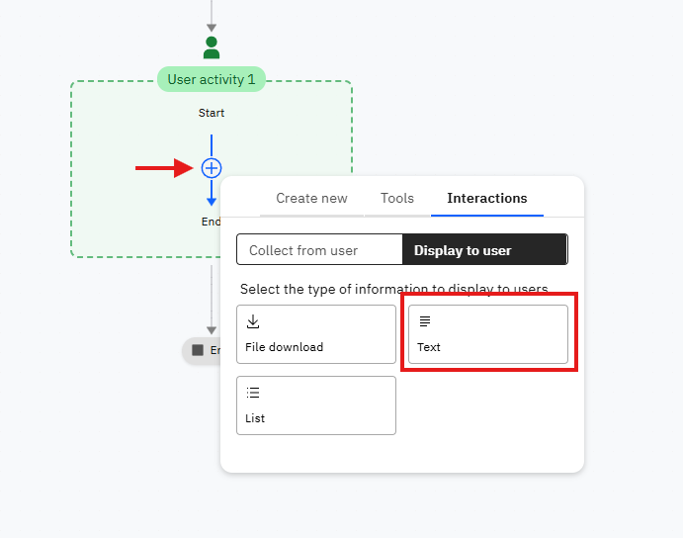

1. Add a File Upload inside the User Activity

* Drag a **File upload** into the User Activity node.
* Rename it to Tax Invoice Uploader.
* 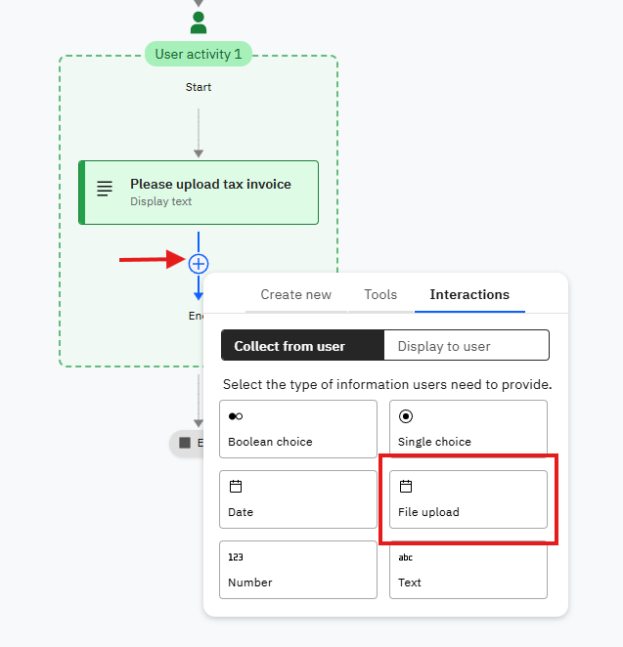Configure it to accept PDF files.

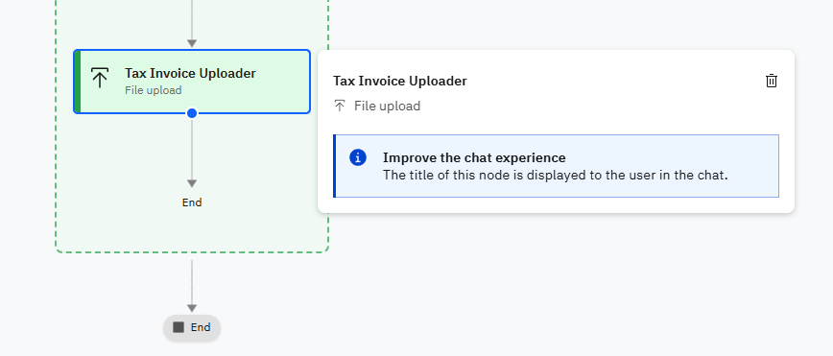

1. 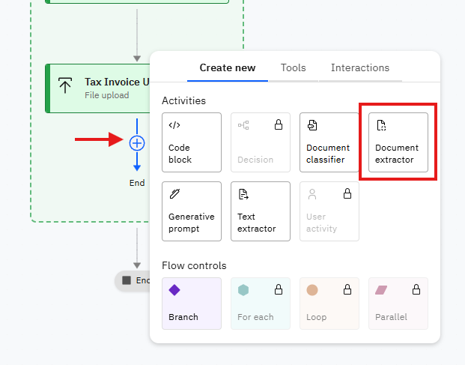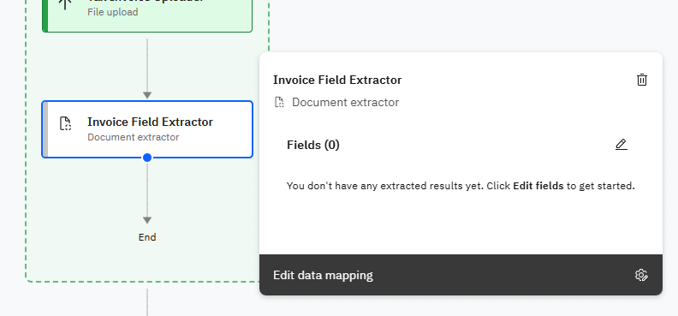Add a Document Extractor inside the User Activity  
   4.1 Drag a Document Extractor into the User Activity node.  
   4.2 Rename it to Invoice Field Extractor.  
   4.3 Click Edit Fields

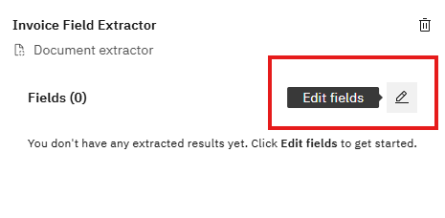

1. Configure Document Extractor Fields  
   The Document Extractor has predefined fields available. For tax invoice validation, we need to configure the following key fields:

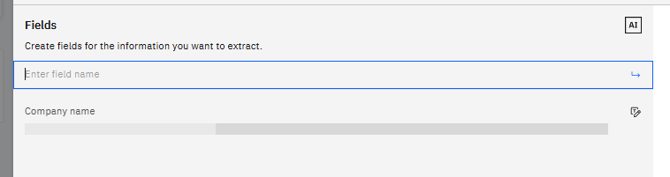

5.1 Configure Invoice date field

Put Description as Extract the invoice date in any format (Thai year, Gregorian year, or short year format)

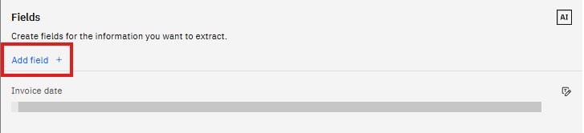

5.2 Configure Seller Company address field

* For Seller Company address Using Description as

Extract the complete Seller’s company address including street, district, province, and postal code. Focus on identifying if the address is located in Thailand.

5.3 Configure Seller Company name field

* For Company name Using Description as

Extract the full Seller’s company name as it appears on the invoice.

5.4 Configure Buyer Company address field

* For Buyer Company address Using Description as

Extract the complete Buyer’s company address including street, district, province, and postal code. Focus on identifying if the address is located in Thailand.

5.5 Configure Buyer Company name field

* For Company name Using Description as

Extract the full Buyer’s company name as it appears on the invoice.

5.6 Configure Seller Company tax ID field

* For Seller Company tax ID Using Description as

Extract the Seller’s company tax ID number. This should be a 13-digit number that represents the company's registration with the Department of Business Development (DBD) in Thailand.

5.7 Configure Invoice number field

* For Invoice number Using Description as

Extract the invoice number or invoice reference number.

5.8 Configure Total Product Price field

* For Total Using Description as

Extract the total price of the product excluding VAT.

5.9 Configure VAT field

* For VAT Using Description as

Extract the VAT amount or tax amount from the invoice.

5.10 Configure Final price with VAT field

* For Final price with VAT Using Description as

Extract the subtotal amount including VAT from the invoice.

5.11 Configure total product price in writing field

* For total product price in writing Using Description as

Extract the total product price written in word string instead of number.

**Added All fields**

**Note:** The Document Extractor provides 11 fields total. You can configure additional fields as needed for your specific validation requirements. The fields shown above are the essential ones for basic tax invoice validation.

1. Add a Generative Prompt for Rule Validation  
   6.1 Drag a **Generative prompt** into the User Activity node.  
   6.2 Rename it to Invoice Validation Agent.  
   6.3 Click Edit to configure the prompt settings.

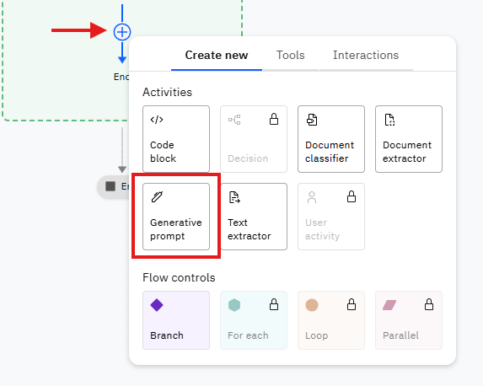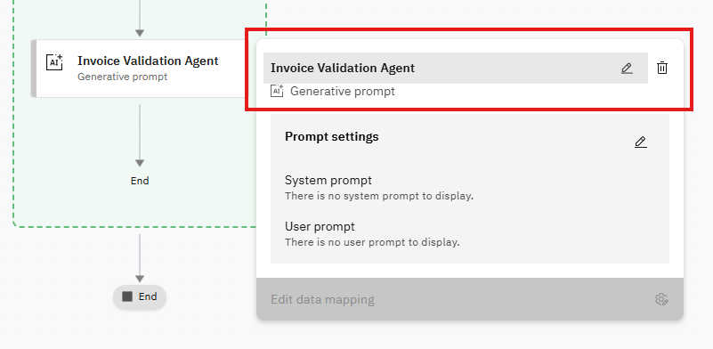

1. Configuration for the Generative Prompt  
     
   7.1 Input variables:

* Name: invoice_date
* Description: The invoice date extracted from the document
* Click Add to save the input variable.
* Name: seller_company_address
* Description: The seller’s company address extracted from the document
* Click Add to save the input variable.
* Name: seller_company_tax_id
* Description: The seller’s company tax ID extracted from the document
* Click Add to save the input variable

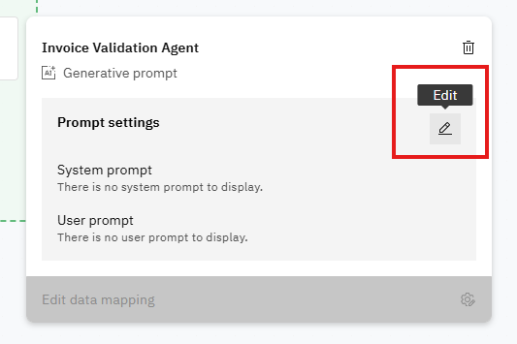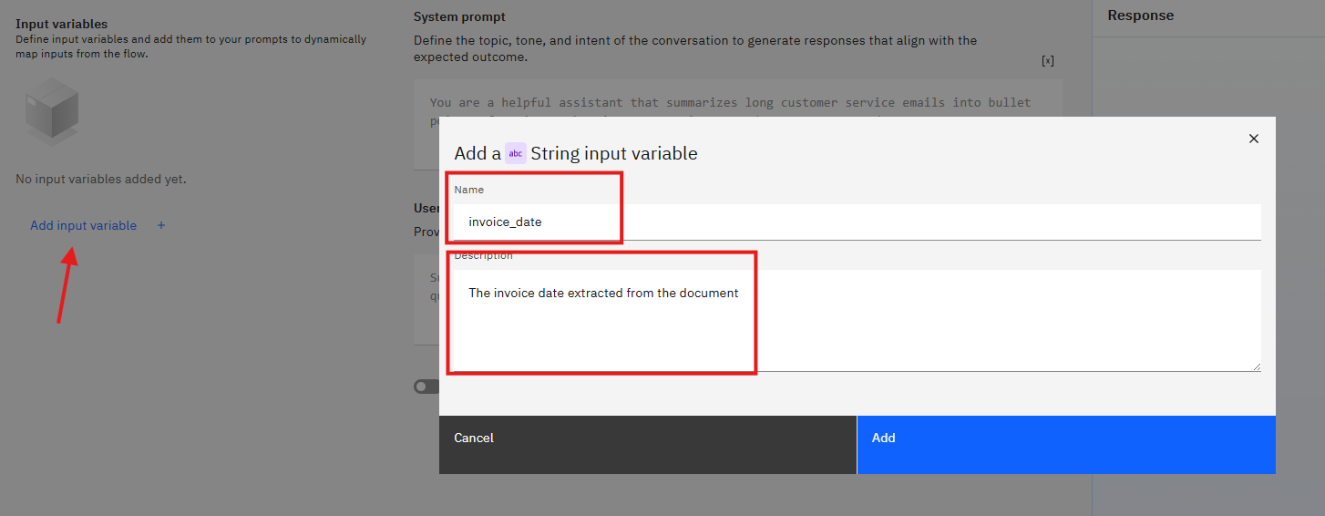

7.2 System prompt (use the exact rules below):

You are an invoice validation assistant.

Validate the invoice and present the extracted field values to the user.

You are an invoice validation assistant.

Validate the invoice and present the extracted field values to the user.

Here are the extracted fields:

- Invoice Date: {invoice_date}

- Company Address: {seller_company_address}

- Company Tax ID: {seller_company_tax_id}

Validation rules:

1. Invoice date must be follow in:

1.1 The current year

1.2 Thai year (พ.ศ.) = Gregorian year + 543.

1.3 Short year with 2 digits (like "60") usually refers to Thai year 2560, not 1960.

1.4 The date is valid ONLY if it falls in the current year (Gregorian 2025 or Thai 2568).

2. Company address must be located in country Thailand.

3. Company Tax ID must be valid according to Thai format (13 digit number)

Please provide answer in Thai language only

7.3 User prompt (what the flow will send to the model):

please provide a result of invoice classification type that whether its qualify or not according to the ruleset please answer in thai language only

You should see similar to this when the prompt is configured.

Click on Adjust LLM settings , then select manually set the creative threshold settings. After that config the parameter according to this picture.

Once done, click generate response and you should get the output similar to the picture below

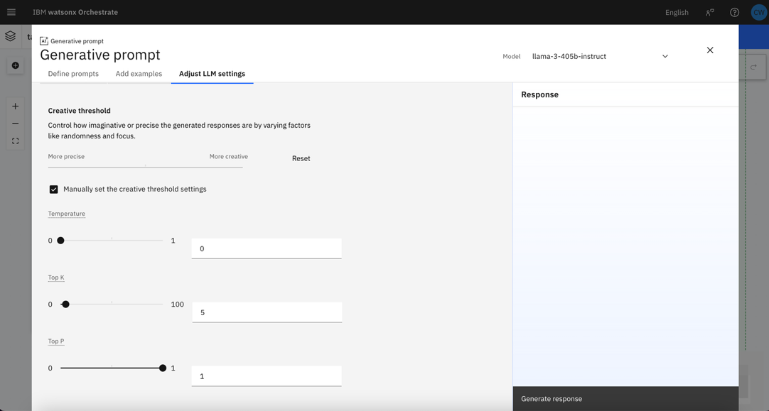

**Checkpoint: Current Workflow would be similar like this**

1. Now, head back to the workflow builder. Add new tool and select import from file

Then upload automation_openapi.json the OpenAPI specification file from lab 2. Once done, click next to progress

Select send_email tools then click Done

Once done, send_email tools should appear on the agent builder screen

**Testing**

Test the agent with these sample inputs:

1. ฉันต้องการตรวจสอบใบกำกับภาษี
2. ช่วยส่งอีเมลผลการประเมิณใบกำกับภาษีไปยัง [chananop.wannatipyaporn1@ibm.com](mailto:chananop.wannatipyaporn1@ibm.com) ให้หน่อย

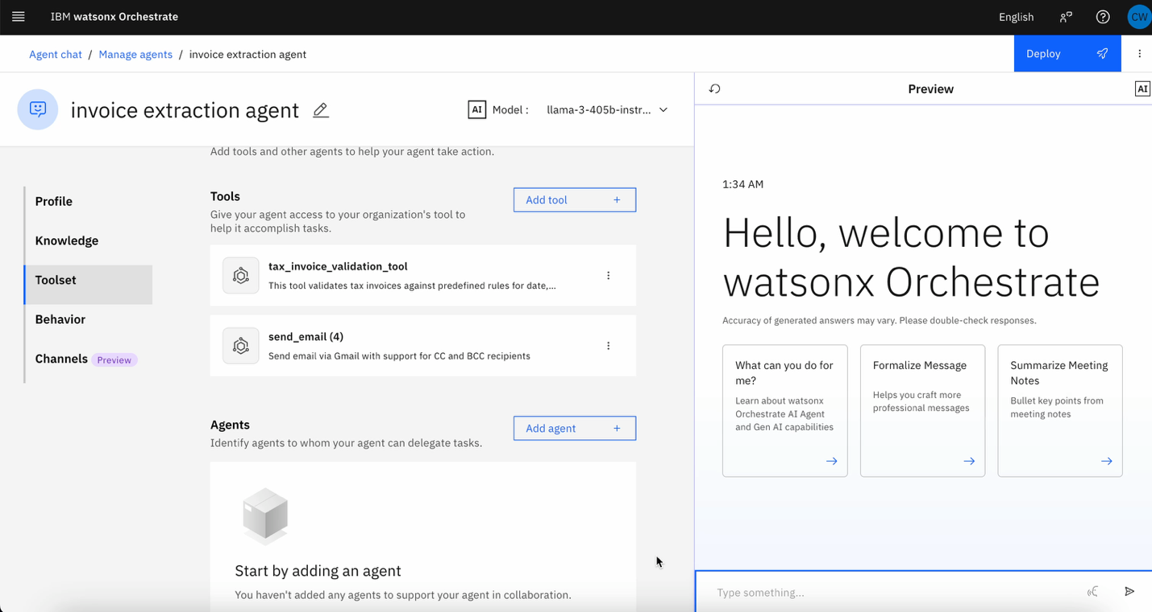

1. The Agent will allow you to upload a tax invoice PDF file
2. The Agent will extract the required fields and validate against the rules
3. The Agent will provide a detailed validation result in Thai
4. The agent will send email of the result in Thai